|  |  |  |  |  |  |
| --- | --- | --- | --- | --- | --- |
|  |  | |  | | --- | | April 2019 Edition | |  | |  | |
|  |  |  |
| Web: www.ask4care.com |  | Compliments of Ask4care support services INC. |

ASK4CARE Employee of The Month for April is Millicent Frimpong!

Millicent is committed to the success of Ask4care, very energetic and self-motivated Millicent’s soothing and angelic voice is what melt our heart as a team.

A few of the character traits she possesses are strong work ethics, dependable, team oriented and very flexible and adapting in a meaningful way. Millicent does not resist change blindly but instead embrace it and adapt to it as it proves necessary. Your beautiful smile adds an innocent touch to your personality.

A Support worker like Millicent can handle each situation and deserves an applaud.

Millicent has people skills by getting the right personality. Always ready to lend a hand to those who need help, appear very calm and gentle as possible even in tough situations. Millicent is open and honest towards the people and resident around her.

Again, your angelic reputation creates a conducive ambiance which we will forever cherish in our heart.



*‘The energy of the mind is the essence of life’.*

***– Aristotle***

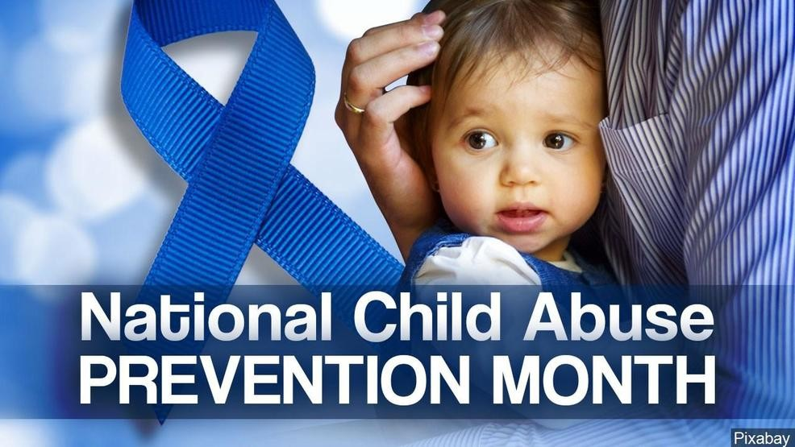

**Risk Factors that Contribute to Child Abuse and Neglect**

Discusses characteristics of parents or caregivers, children, families, and communities associated with increased risk of child abuse or neglect.

Perpetrators

Identifies the characteristics of perpetrators, including those who commit certain types of abuse.

Impact

Explores how abuse and neglect affect children, adolescents, adult survivors, and society.

Fatalities

Addresses the occurrence of child fatalities, perpetrator characteristics, and risk factors.

Preventing Child Abuse & Neglect

Resources on child abuse prevention, protecting children from risk of abuse, and strengthening families. Includes information on supporting families, protective factors, public awareness, community activities, positive parenting, prevention programs, and more. Also access the National Child Abuse Prevention Month website.

Overview

Understanding child abuse prevention and what to do when children are at risk. Includes frequently asked questions and links to related Federal and national organizations and State contacts that work to prevent child abuse.

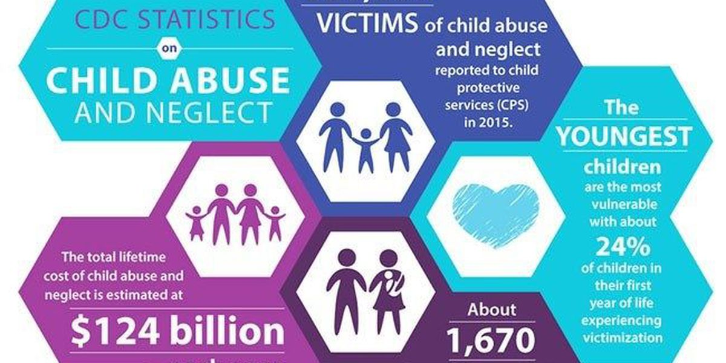

Promoting child & family well-being

Information on well-being and ways programs and systems can support it. Includes resources on protective factors, marriage, fatherhood, and parenting.

Public awareness & creating supportive communities

Tools for sharing a child abuse prevention message with your community and building community support.

Prevention programs

Standards for prevention programs, research on what works, information on the role of related professionals, and resources for specific types of programs.

Developing & sustaining prevention programs

Considerations for managing a prevention program, including community needs assessment, collaborating with community partners, family engagement and retention, cultural competence, training, and funding.

Evidence-based practice

Child abuse prevention programs and strategies supported by scientific research.

Evaluating prevention programs

Evaluating program effectiveness and conducting cost analyses. Features the Evaluation Toolkit and Logic Model Builder.

Responding to Child Abuse & Neglect

Resources in this section can help child welfare professionals protect children's safety, support families, and help prevent child maltreatment. They include resources for administrators and managers and information on reporting suspected child abuse and neglect; intake, investigation, and assessment of reports; addressing trauma; and collaborative responses.

Overview

Policies and frequently asked questions.

Resources for administrators & managers in child protective services

Building systems, funding, training, and community responses.

Reporting

Systems to receive and respond to reports of suspected child abuse and neglect, including mandated reporting.

Screening & assessment in child protection

Screening and investigating reports, assessing safety and risk, and responding to types of neglect and abuse.

Differential response in child protective services

Also called differential responses, multitrack responses, and dual-track responses, resources include examples of current State programs.

Child protection casework practice

Decision-making, safety planning, and casework practice to work with families and perpetrators. Includes evidence-based programs.

Responding to child fatalities & near fatalities

Investigating and responding in cases of possible child maltreatment deaths, including resources on child death review teams.

Trauma informed practice

Building trauma-informed systems, assessing and treating traumatized children and families, resources for caseworkers and families, secondary trauma, and training.

Collaborative responses to child abuse & neglect

Resources and information about collaboration among public child welfare and other human service agencies, such as law enforcement, courts, and medical professionals.